John Rene Lorelli

Data ScienceFoundations

Week 10

M10 Exercise FunctionalFormFitting

1. The entire R code used when creating the scatter plot in (1), and the quadratic curve in (2).

p<-read.csv("penguin.csv")

plot(p$Penguins, p$Year, xlab="Penguins", ylab="Years", main="Number Penguins Per Year")

> a<-p$Year

> b<-p$Penguins

> plot(a, b, pch=20, main="Number of Penguins vs Years" )

> quad<-lm(a~b+bSqu)

> aSqu<-a*a

> quad1<-lm(b~a+aSqu)

> s<-seq(0,90,2)

> pc<-predict(quad1, list(a=s, aSqu=s^2))

> lines(s, pc, col="red", lwd=4)

* I think there was an issue with the sequence but I used the one from the video.
* I experiments with year and penguins for quad but neither gave me a line.

1. Screenshot of the scatter plot created in (1) with the quadratic curve created in (2).

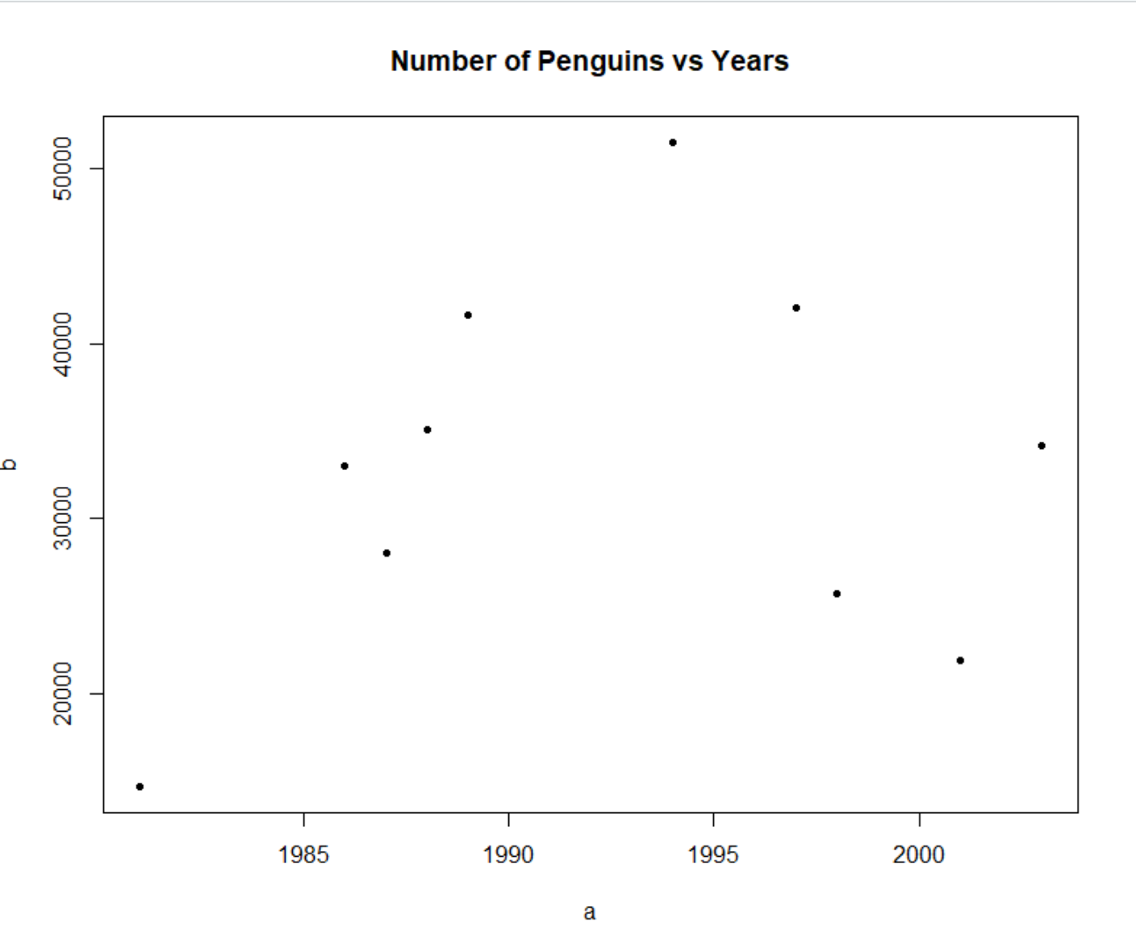

1. Your opinion about the correlation (or lack thereof) between Penguins and Year.

Even though there was a line refused to draw. I would see there is a lack of correlation just by looking at it. I am unable to see any type of curve.

1. The entire R code used when creating the scatter plot in (4), and the exponential/logarithmic curve in (5).

> beerfroth <- read_csv("beerfroth.csv")

> View(beerfroth)

> t<-beerfroth$Time

> f<-beerfroth$Foam

> plot(t, f, main="Beer Foam against Time", xlab="Time", ylab="Foam")

> em<-lm(log(f)~t)

> pd<-exp(predict(em, list(t)))

> lines(t, pd, col="green", lwd=4)

1. Screenshot of the scatter plot created in (4) with the exponential/logarithmic curve created in (5).

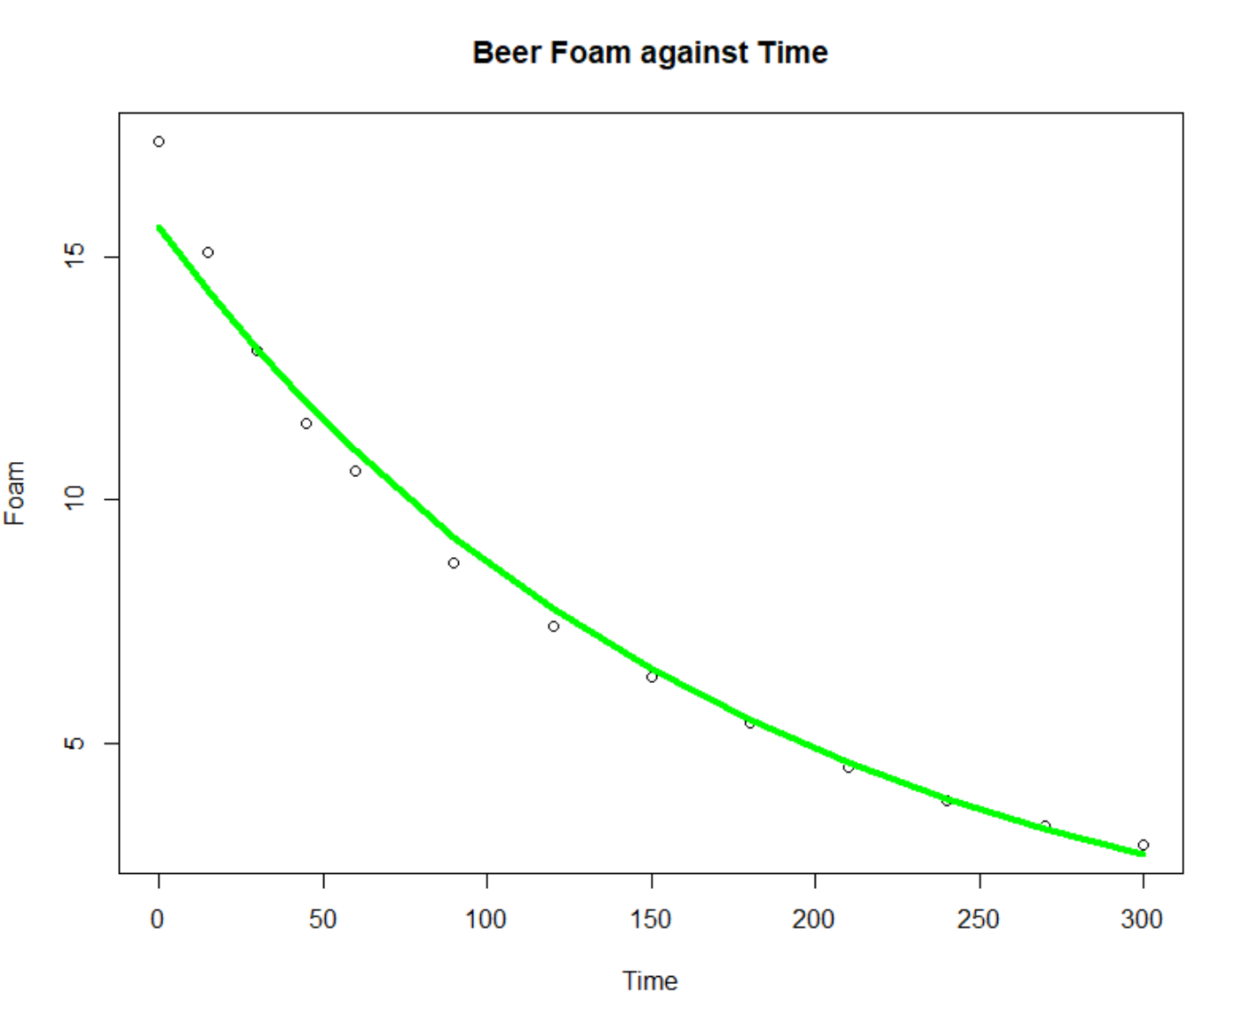

1. Your opinion about the correlation (or lack thereof) between beer foam height and time.

This is a very good correlation between foam and time. The exponential curve is almost exact.